CURRICULUM VITAE



**OBJECTIVE :-**

Looking for an Industrial Training or Internship opportunity in hotel industry to showcase and enhance my practical and technical skills and to get hands on experience in real environment.

**ACADEMIC PROFILE :-**

**2020-2023 :** Pursuing B.Sc. H&HA(3rd Semester) from IHMRanchi affiliated to National Council for Hotel Management & Catering Technology.

**10TH (C.B.S.E) :** K.V No-1 Sector- IV, Bokaro Steel City with 53.8% ,2017

**10+2 (JAC Board)** : RVS College, Bokaro Steel City with

56.20 %, 2019 (**Science**)

**COMPUTER PROFIENCY :-**

* Proficient working with MS OFFICE.

**COMPETENCIES :-**

* Communication Skills, Positive Attitude
* Leadership Quality, Honest & Hard-Working.
* Consistent & Versatile.

**AREA OF INTEREST:-**

Food production, F&B Service, Front office and Accommodation operation.

**DECLARATION**

I hereby declare that the above details are true to the best of my knowledge.

**Place: BRAMBE, RANCHI**

**(NISHANT)**



**Nishant**

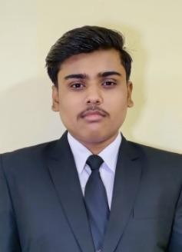

# E-Mail :-

[nishantkr479@gmail.com](mailto:nishantkr479@gmail.com)

# Permanent Address :-

Plot no. 796,

Bari co-operative colony Bokaro Steel City Jharkhand

Pin – 827010

# Contact No :-

7005063223 , 7254803061

# Personal Profile :-

**Father’s Name :** Prakash Kumar **Date of Birth :** 26/08/2002 **Nationality :** Indian

**Marital Status :** Unmarried

**Language proficiency :-** Hindi and English **Interests and Hobbies:-**

Cooking, Playing Cricket and Travelling.